 | OPTIONS FOR ACTION SUMMIT  to address U.S. competitiveness in global standardization activities  July 18-19, 2006 | Gaithersburg, Maryland
  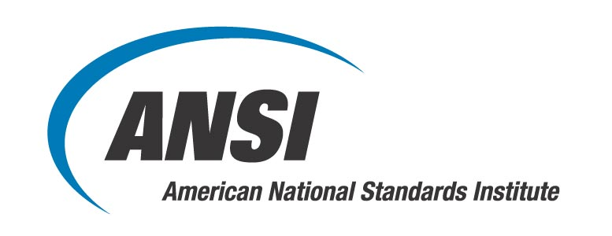 | 
 | Reply requested by July 7, 2006
Venue  National Institute of Standards  and Technology (NIST)  100 Bureau Drive  Gaithersburg, MD 20899-3460  Conference Schedule  July 18: 8:30 am – 5:30 pm  July 19: 8:30 am – 4:30 pm  Registration  For security purposes, advance registration is required.  Please reply by July 7, 2006.  Fees Complimentary  Program  Please see event webpage.  Accommodations  Hilton Washington DC *  1-800-599-5111  Room rate: $139.00 (book before June 19)  Holiday Inn Gaithersburg *  301-948-8900 or 1-800-465-4329  Room rate: $104.00 (Monday July 17 only; book before June 26)  * Must mention the Options for Action Summit and reserve by date indicated to receive the negotiated rate.  Questions or Additional Information?  Mr. Steven Cornish  American National Standards Institute  T: 212.642.4969  E: scornish@ansi.org
  Name | first name, middle initial, last name
  Title
  Organization
  Address
  City
  State | Zip Code
  Country | United States of America
  E-mail
  Telephone
  I understand that pre-registration is required for access to the
  NIST facility and that I must show proper credentials (photo ID)
  at the security gate during check-in. (U.S. citizens: driver’s license or other photo identification; international guests: passport)
  Fees $0.00 – Complimentary for the two-day event
  (breaks and lunch will be provided on both days)
  Social ANSI and NIST invite you to attend a networking reception on
  Event Tuesday evening, July 18, following the Day One events.
  Please complete and send this form to the ANSI Registration Coordinator:
  Email: registration@ansi.org
  Fax: 212.398.0023
  Post: Registration Coordinator, American National Standards Institute
  25 West 43rd Street - Fourth floor, New York, NY 10036

